
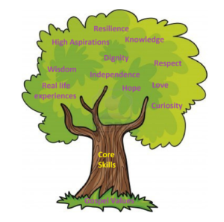

Units: White Rose – Habitats and Deforestation
Key questions/ experiments:
What is a habitat? What do living things need to survive? What is a classification key? How do habitats support a plants need for survival? What is deforestation? What are the impacts of deforestation?
Art/Design Technology
Text: Greek Myth
Writing to Inform: Diary entry
Skills: conjunctions, different sentence types, descriptive language, SPAG.
DT – Digital World – Wearable technology
Give a brief explanation of the digital revolution and/or remember key examples. Suggest a feature from the virtual micro:bit that is suitable for the product. Write a program that initiates a flashing LED panel, or another pattern, on the virtual micro:bit when a button is pressed. Identify errors, if testing is unsuccessful, by comparing their code to a correct example. Evaluate design.

Unit: Computational Thinking
Understand that problems can be solved more easily using computational thinking. Recognise decomposition, abstraction, algorithm design and pattern recognition as key computational thinking skills. Explain how decomposition and abstraction simplify problem-solving. Identify patterns in problems and use them to solve problems. Design clear algorithms and justify their choices. Create logical sequences of steps to complete a task or project. E-Safety: What is my tech timetable like?
Use computational thinking skills to code, refine and evaluate their work.
Overview: E-Safety: What is a bot?
Unit: Geography
Key Question: Why do people live near volcanoes?
What are the positive and negative effects of living near a volcano? Where are volcanoes located? Where is the Ring of Fire located and what is it? How do climates have an impact on trade, land use and settlement?
Unit: Relationships
Overview: To recognise that there are different types of relationships. To know that people may be attracted to someone emotionally and romantically. To know that people may be attracted to someone of the same sex or different sex to them; that gender identity and sexual orientation are different. To know about marriage and civil partnership are a legal declaration of commitment made by two adults who love and care for each other.

Unit: The 8-Fold Path
Religion: Buddhist World Views
Key Question: What is the best way for a Buddhist to lead a good life?
Religious Education
Unit: Romans
Key Skills: Learn a new song, singing in time and in tune while following the lyrics. Identify motifs aurally and play a repeated pattern on a tuned instrument. Create and performing a motif, notating it with reasonable accuracy.
Transpose their motif, using sharp or flat notes where necessary and change the rhythm.
Combine different versions of a musical motif and perform as a group using musical notation.
Year 3 Curriculum Overview – Summer 1

Units: White Rose – Fractions
Objectives include:
Comparing and ordering fractions, understanding denominators, fractions on a number line, fractions in a bar model.
PSHE
Cricket: Underarm and overarm throwing, overarm bowling, batting, two handed pickup.
Forest School: To nurture self-esteem, learn to work as a team and improve communication skills, develop map skills.

Physical Education
English
Science
Mathematics
Computing
Humanities
Music

