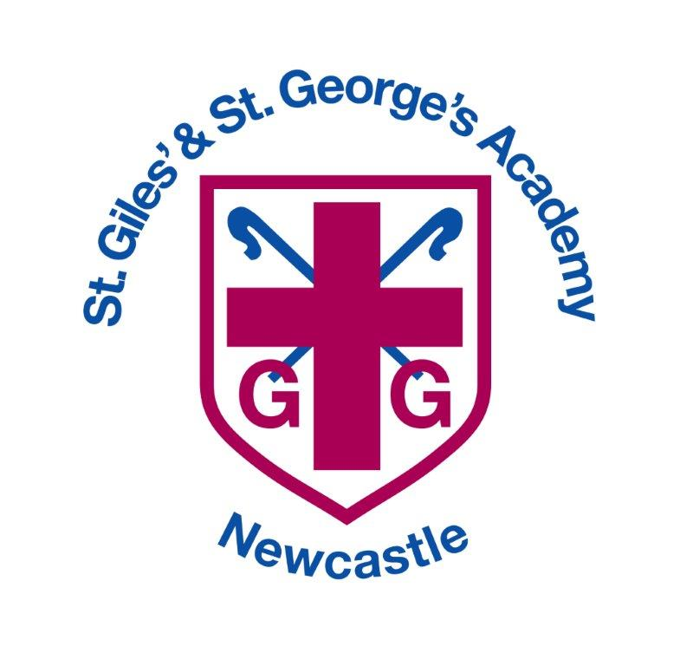

Healthy Eating Policy

**Date policy reviewed: March 2025**

|  |  |
| --- | --- |
| **Signed by** | **Date** |
| **Headteacher:** |  |
| **Trust:** |  |

# Policy source

St. Giles and St George’s C of E Academy’s Healthy Eating Policy reflects advice regarding school food standards published by the DfE and last updated (September 2023)

# Arrangements for Monitoring and Review

This policy shall be reviewed in full by the Local Academy Committee at least once every three years in accordance with the schools Year Planner. The person named on this policy shall inform the governing body of any changes to the model policy or to statutory or non-statutory guidance.

The Local Academy Committee will receive regular reports on compliance with the school food standards as well as take-up of school lunches and financial aspects of school food provision.

Parents are signposted to this policy when their child joins the school, so they are aware of the school’s commitment to maintaining a healthy school community.

This policy will be monitored and evaluated through normal lesson observations and through pupil and parent surveys.

# Introduction

At St. Giles and St George’s C of E Academy we understand a healthy balanced diet is key to an individual fulfilling his or her full potential in life. We believe it is important to enjoy a varied and interesting diet while understanding that certain food groups should be eaten in moderation.

# Vision

At St. Giles and St George’s C of E Academy’s we strive to ensure that:

* Our children are served tasty and nutritious food at school, with no child going hungry.
* We take a ‘Whole School Approach’ to food, with creative collaborations between the head teacher, school cook and kitchen staff, children, staff, governors and parents.
* Our children will know how to feed themselves well, and will enjoy cooking and growing with their families, both at school and at home; embedding a *whole school culture of health.*

# Objectives

The Local Academy Committee and staff aim to:

* Take a Whole School Approach to healthy eating to ensure that messages taught in the curriculum are echoed and reinforced by the type of food and drink provided in school.
* Ensure that all aspects of food and nutrition at St. Giles and St George’s C of E Academy’s promote the health and well-being of the whole school community.
* Encourage children to develop healthy diet habits and attitudes – eating more fruit and vegetables, eating less sugar and fat and drinking more water.
* Enable pupils to make healthy food choices through the provision of information about healthy foods and where food comes from and the development of appropriate skills, including food preparation.
* Ensure that all adults in our school community are aware of this approach and work towards it.

# Food in school

Midday staff in the dining hall encourage an atmosphere that promotes healthy eating and develops social interaction between the children.

The school provides in house catering for our lunchtime meals service.

All meals served adhere to national food standards, which ensure that food provided to pupils in school is nutritious and of high quality; to promote good nutritional health in all pupils; protect those who are nutritionally vulnerable and to promote good eating behaviour. The checklist for School Lunches is shown at Appendix 1.

The menu rotates over three weeks and a new menu is issued twice a year. At the start of each school day, the children choose the lunch they would like from a choice of vegetarian or non- vegetarian hot meal or a ‘packed lunch’ option.

School lunch menus are distributed to parents and are available on the school’s website; the week’s menu is displayed for children in the dining hall and on the external noticeboard.

Children are encouraged to eat all or at least try to eat most of the food provided.

Lunchtime supervisors will help any children who have concerns or cause concern during meal time, e.g. children who may have problems eating their lunch, spill or drop their lunch, cannot find a place to sit, do not eat their lunch or skip lunch, etc.

A school lunch must be provided for pupils where a meal is requested and either the pupil is eligible for free school lunches, or it would not be unreasonable for lunches to be provided.

Special dietary requirements Individual care plans are created for pupils with food allergies/food intolerance. These document symptoms and adverse reactions, actions to be taken in an emergency, and emergency contact details. ***Please note that our catering team do not knowingly buy nuts or anything containing nuts, however within our supply chain some of our suppliers say “nut traces may be present in their products” and or “produced in a factory that contain nuts”.***

The school will provide a photograph to enable the kitchen staff to identify children with special dietary requirements.

Universal Free School Meals. From September 2014, all children in reception, year 1 and year 2 have been eligible for free school lunches. The school fully supports this initiative, encouraging children to have their free school meal. Research shows that a school lunch is nutritionally superior to most packed lunches and can lead to improved behaviour and attainment.

Encouraging take up of school meals through the school newsletters, parents on low incomes will regularly be encouraged to register and take up their entitlement to free school meals for their children.

Where practical, the school will seek opportunities for some parents to eat a school meal with our younger children on special occasions if possible.

Packed lunches from home. Although the governors encourage parents to choose a school meal for their child, children are permitted to bring a packed lunch from home, but it should be noted that sweets, chocolate, chewing gum and fizzy drinks are not permitted in school.

**Ideas for a healthy lunchbox can be found at** <https://www.nhs.uk/healthier-families/recipes/healthier-lunchboxes/>

Children are encouraged to eat all or at least try to eat most of the food provided by their parents. All litter from packed lunch must be taken home in the packed lunch box.

Morning snacks. EYFS and Key Stage 1 children have fruit and vegetables provided for them by the School Fruit and Vegetable Scheme. KS2 children are encouraged to bring a fruit or vegetable snack from home for break time.

Water for All. Children are encouraged to bring a water bottle to school and enabled to drink water throughout the day: regular water and brain breaks are built into the school day and curriculum by class teachers.

Milk is an important source of nutrients for growing children and the school food standards require lower fat milk or lactose reduced milk to be available for drinking at least once a day during school hours. (Whole milk can be provided for pupils up to the end of the school year in which they reach age 5.)

All children children are able to order milk from Cool Milk for break time.

Under the Nursery Milk Scheme, operated by the Department of Health, free milk is provided to children under the age of 5. Milk is also free to benefits-based free school meals pupils; a charge is made for all other pupils.

Confectionary. Children are not allowed to have sweets, chocolate, chewing gum or fizzy drinks in school. Children are encouraged to bring in a book to present to the class rather than sweet treats.

The school does not encourage the regular eating of sweets or other foods high in sugar or fat, especially as a reward for good behaviour or academic or other achievements. Other methods of positive reinforcement are used in school.

# Curriculum

Cooking and Nutrition. The new primary curriculum for Design and Technology includes Cooking and Nutrition and emphasises the importance of cooking nutritious, savoury dishes, understanding where food comes from, and taking pleasure in the creative arts of the kitchen. Pupils should be taught to:

Key stage 1

* + - use the basic principles of a healthy and varied diet to prepare dishes
    - understand where food comes from.

Key stage 2

* + - understand and apply the principles of a healthy and varied diet
    - prepare and cook a variety of predominantly savoury dishes using a range of cooking techniques
    - understand seasonality, and know where and how a variety of ingredients are grown, reared, caught and processed.

Food across the Curriculum in addition, topics in Science, PHSE and PE address the benefits of healthy eating to promote physical and mental wellbeing and there are a number of opportunities for pupils to develop knowledge and understanding of health, including healthy-eating patterns and practical skills such as shopping, preparing and cooking food. See Subject Learning journeys for details.

**Forest Schools** is an integral part of our curriculum and during certain sessions children are offered hot drinks such as hot chocolate and we use UHT milk for this purpose which is opened fresh for each session. The children are taught how to cook simple foods outdoors, following all health and safety requirements and using only plant based/ vegetarian products.

All utensils, plates, cups will be checked to ensure they are clean before use.

Children with allergies are identified prior to commencing the course and their needs catered to ensure their safety and inclusion in the activities offered.

Fresh food shall be stored as required, in the fridge if necessary and used well within use-by dates.

Foods to be cooked/toasted/melted during Forest School sessions include: potatoes, peppers, onions, mushrooms, corn on cob, bread, bagels, eggs, cheese, vegetarian marshmallows, chocolate.

Food shall be handled according to outdoor hygiene (hand wipes), thoroughly cooked and checked by the FS leader.

All foods requiring refrigeration will be stored in a cool box and used within 2 hours. Meat, products containing gelatine and products containing nuts will **not** be used.

Basic food hygiene training is carried out by staff members who are involved in food handling.

# Partnership with Parents and Carers

The partnership of home and school is critical in shaping how children and young people behave, particularly where health is concerned.

Parents and carers are regularly updated on our water and packed lunch policies through school newsletters. We ask parents not to send in fizzy drinks and we remind them that only water may be drunk during the school day, except at lunchtimes when children may drink juice or squash (water or milk only is provided for children who have a school meal).

During out of school events, e.g. school trips and parties, the school will encourage parents and carers to consider the Food Policy in the range of refreshments offered to the child.