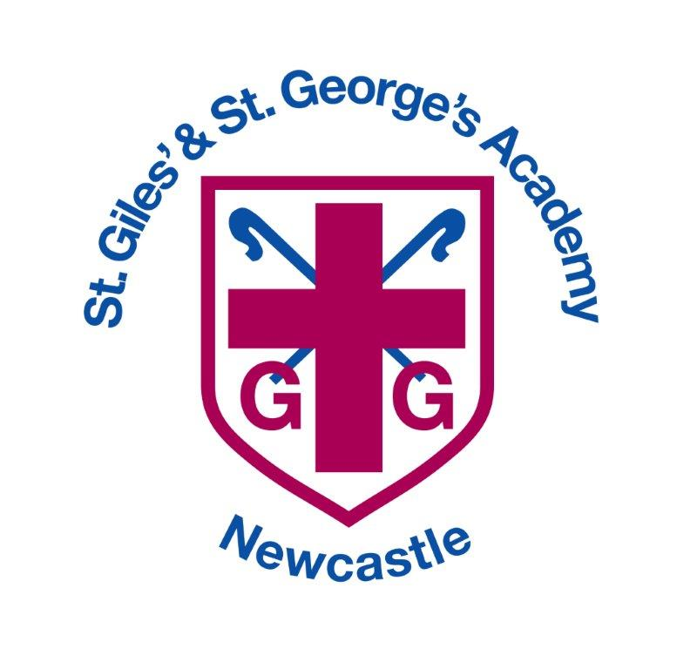

Uniform Policy

**Date policy reviewed: March 2025**

|  |  |
| --- | --- |
| **Signed by** | **Date** |
| **Headteacher:** |  |
| **Trust:** |  |

**Purpose**

It is our school policy that all children wear school uniform when attending school, or when participating in school-organised events outside normal school hours. We ask children to wear their shirts tucked into their skirts or trousers and to take a pride in their personal appearance. Some items of uniform can be bought from SMART uniform shop in Newcastle Under Lyme, whilst others are easily available, at very competitive prices, at local shops including supermarkets. A complete list of the items needed for school uniform including those for Physical Education, is printed in the appendix.

**Aims**

Our policy on school uniform is based on the belief that school uniform:

* promotes a sense of pride in our school;
* helps to create a sense of community and belonging towards the school;
* identifies the children with the school;
* supports our commitment to inclusion;
* prevents children from wearing ‘fashion clothes’ that could be distracting in class;
* is practical, smart and designed with health and safety in mind;
* is considered good value for money by most parents;

# Jewellery, Hair Ornaments, Make-up and Nail Varnish

For health and safety reasons we do not allow children to wear jewelry. The exceptions to this rule are small objects of religious significance and small stud earrings. Children are required to remove any items during PE lessons to prevent them from causing injury if possible. Hair bands, ribbons/bows or ‘scrunchies’ should be plain and either maroon, white or navy. Hair bands should not have large flowers attached. Make up and nail varnish should not be worn to school unless for an out of school hour’s function, for example a school disco. Extreme hairstyles are not appropriate for school. The use of styling products should be kept to a minimum and children should not have decorative patterns cut into their hair or have hair coloured or dyed.

# Footwear

For health and safety reasons we do not allow children to wear shoes with platform soles or high heels. All children are required to wear plain black shoes as stated in the uniform list. If boots are worn these should also be plain black. If boots are large and prevent children from sitting comfortably on the floor, they may be asked to change into their PE shoes whilst inside the school building. Trainers are to be worn on PE days only.

# The Role of Parents

We believe that one of the responsibilities of parents is to ensure that their child has the correct uniform and PE kit, and that it is clean, in good repair and that the child’s name is written on all items. If a parent has difficulties for any reason with fulfilling this request, they are asked to speak confidentially to a senior member of staff to discuss the issues. Parents should be assured that we will do all we can to help. Children who arrive at school wearing non-school uniform clothing will be loaned an appropriate item from our nearly new shop to wear for that day. The same system will apply for children who do not have a PE kit. Parents will be contacted to discuss the matter. The school welcomes children from all backgrounds and faith communities. If there are serious reasons, for example on religious grounds, why parents want their child to wear clothes that differ from the school uniform, the school will consider such requests sympathetically. If any parent would like to request a modification to the uniform policy they should, in the first instance, contact the headteacher.

# The Role of Local Academy Committee

The LAC support the headteacher in implementing the school uniform policy. They consider all representations from parents regarding the uniform policy and liaises with the headteacher to ensure that the policy is implemented fairly and with sensitivity. It is the Directors’ responsibility to ensure that the school uniform meets all regulations concerning equal opportunities.

Directors ensure that the school uniform policy enables children to dress sensibly, in clothing that is hardwearing, safe and practical.

# Monitoring and Review

The LAC monitor and reviews the school uniform policy through its committee work by:

* seeking the views of parents, to ensure that they agree with and support the policy;
* considering, with the headteacher, any requests from parents for individual children to have

special dispensation with regard to school uniform;

**Appendix A**

# School Uniform List

Our school uniform colour is a combination of navy and maroon. Most items can be bought from High Street shops. Items marked with a * below, some of which have the school logo on, are sold through school, plain items without a logo are also acceptable. Please speak to our office staff for details of prices.

# For girls:

* Grey skirt/pinafore dress/shorts/trousers or navy and white checked dresses
* White polo shirt (EYFS and KS1), white shirt (KS2)
* School tie (KS2)
* Navy sweatshirt* or cardigan*, without a hood, either plain or with the St Giles’ and St George’s logo
* Plain black/white short or knee length socks (not over the knee) or black or grey tights
* Navy blue check summer dress (April-Oct)

# Please note skirts should be an appropriate length and of a style which allows girls to sit comfortably on the floor. When girls wear shorts, even when these are worn over tights, they should also be of an appropriate length. Three-quarter, calf length, leggings should not be worn.

# For boys:

* Grey shorts or trousers **not** jogging bottoms
* White shirt (KS2) or white polo shirt (EYFS and KS1)
* School tie (KS2)
* Dark navy sweatshirt, without a hood, either plain or with the St Giles and St George’s logo*

Reversible waterproof coats, with the school logo, which are suitable for boys and girls, are also available from SMART Uniform.

Shoes should be flat, black, closed toe and appropriate for school. Your child should wear shoes which he or she can manage to do up independently Please do not send your child to school in shoes which prevent them from running in the playground. If boots are worn these also should be plain black. Children who wear boots that prevent them from sitting comfortably on the floor may be asked to wear their PE shoes whilst inside the building. Trainers are only to be worn on PE days.

# P.E. and EYFS Uniform

* Navy T-shirt either plain or with St Giles and St George’s logo*
* Navy jogging bottoms, leggings or shirts plain or with St Giles and St George’s logo*
* Navy Hoodie plain or with St Giles and St George’s logo.