Pupil Premium Policy



Approved by: |  | Date: June 2021
Last reviewed on: | June 2021
Next review due by: | June 2022

PURPOSE

The Pupil Premium is a government initiative that targets extra money at pupils from deprived backgrounds. Research shows that children from deprived backgrounds underachieve compared with their non-deprived peers. The premium is provided to enable these children to be supported to reach their potential. The Government has used children entitled to free school meals (FSM). Looked after children and service children as indicators of deprivation, and have provided a fixed amount of money for schools per child based on the number of pupils registered for FSM (for any length of time) over a rolling six year period. These children are knows as our Ever 6 group.

ETHOS

St Giles and St Georges C of E Academy offers a positive, inclusive, safe learning environment for its learners, in which everyone has equal and individual recognition and respect. We celebrate difference and are committed to the continuous improvement and fulfilment of potential in every child. We encourage increasing independence and confidence amongst the children. Everyone within the school has an important role to play in sharing responsibility for the development of positive attitudes to learning and excellent behaviour.

AIMS
We have high aspirations and ambitions for our children and we believe that every child matters. By undertaking the approaches identified in our core offer, the school aims to raise levels of:

- self-esteem and confidence
- progress and achievement
- attitude towards learning and attendance
- well-being and mental health
- access to after school clubs

KEY PRINCIPLES
- We have high expectations for all pupil groups and individuals. We do not equate deprivation with low ability and expectations.
- We recognise that not all pupils who are eligible for the pupil premium are socially disadvantaged and that not all socially disadvantaged pupils attract pupil premium funding. We therefore focus on the needs and progress of all our pupils.

- Research, trialling and self-evaluation are used in order to allocate pupil premium funding to activities that are most likely to have an impact on achievement.

- We ensure that the provision of additional support does not socially isolate pupils. Extra help is integrated into the teaching programme and it is likely that intervention groups will be a mix of pupils who are eligible for the pupil premium and those who are not.
- Engagement with all parents is fundamental to promoting improved outcomes for our pupils
- All pupils eligible for funding, including those who are working above ARE or those who demonstrate potential to work above ARE will access support to raise levels of progress, attainment, attendance, well-being and mental health and self-esteem and confidence.
CORE OFFER
See Separate document
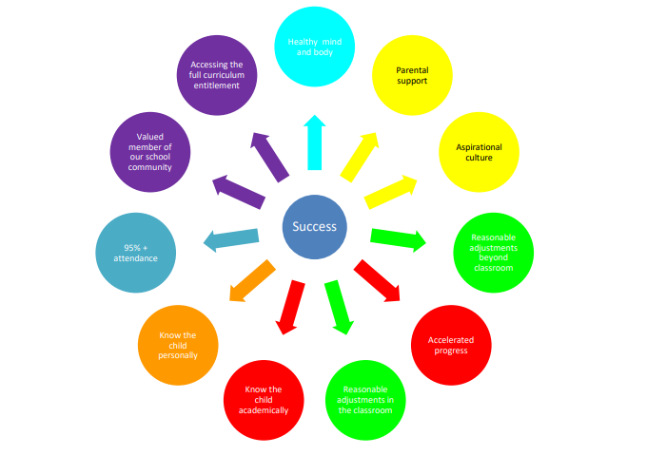
ROLES AND RESPONSIBILITIES
  - The Headteacher will approve the overall strategy for deploying Pupil Premium funding prepared by the PP Lead (Mrs Barclay) and presented in the PP Strategy

  - The PP Lead is our Pupil Premium Champion and evaluates the quality of provision and impact of our core offer on a termly basis and provides solutions where barriers occur.

  - The Finance and Resources Governors committee are responsible for the reporting of pupil premium spending and its impact on a termly basis to all governors.
Class teachers
  - All staff are expected to have an in-depth knowledge of all the children they teach and support, especially those children identified in a vulnerable group.
  - All teachers are accountable for the progress made by the children they teach.
  - All staff will ensure they adopt teaching and learning strategies that meet the needs of individuals and groups via quality first teaching.
  - All staff will ensure the core offer for our pupil premium children is provided
  - All staff will provide clear feedback that enables children to improve their work.
  - All staff will active engage and support parents in working effectively with their children at home and in school
MONITORING AND EVALUATION
We will be monitoring and evaluating the achievement of our Pupil Premium pupils as an individual group in comparison to all other pupils within our school via the analysis of our internal teacher assessment and standardised testing, attendance data and behaviour logs, pupil interviews and any other specific monitoring activity on a termly basis

